Morning Azkar

  **And mentionthe name of your Lord in prayer, Morning and Evening**[Al quran 76:025]

**Play All Du'a**

Audio Player

00:00

[Use Left/Right Arrow keys to advance one second, Up/Down arrows to advance ten seconds.](javascript:void(0);)

00:00

[Use Up/Down Arrow keys to increase or decrease volume.](javascript:void(0);)

**Dua 1**

**Recite ONCE Between Asr to Magrib**

**Arabic**

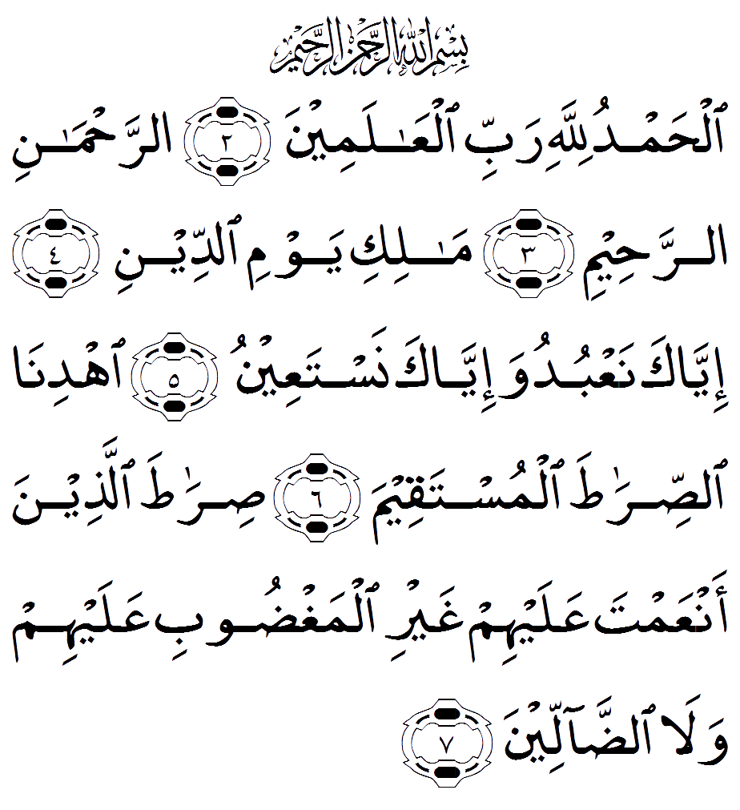

**Play Du'a**

**Reference**

Sura Al-Fateha

**Pronunciation**

1. Bismi Allahi arrahmani arraheem.

2. Alhamdu lillahi rabbi alAAalameen

3. Arrahmani arraheem.

4. Maliki yawmi addeen.

5. Iyyaka naAAbudu wa-iyyaka nastaAAeen.

6. Ihdina assirata almustaqeem.

7. Sirata allatheena anAAamta AAalayhim ghayri almaghdoobi AAalayhim wala addalleen.

**Translation**

1. In the name of Allah , the Entirely Merciful, the Especially Merciful.

2. [All] praise is [due] to Allah , Lord of the worlds.

3. The Entirely Merciful, the Especially Merciful.

4. Sovereign of the Day of Recompense.

5. It is You we worship and You we ask for help.

6. Guide us to the straight path.

7. The path of those upon whom You have bestowed favour, not of those who have evoked [Your] anger or of those who are astray

**Hadith/Benefit**

Allah responds to the believer when he recites Surah Al-Fatiah.

Abu Hurayrah (R.A) who said that the Messenger of Allah (S.A.W) said “Allah, the Glorious and Exalted said, “I have divided the prayer between myself and my servant equally and my servant shall be granted what he asked for”.

Allah responds to the believer when he recites Surah Al-Fatiah.

[Sahih Muslim]

break

**Dua 2**

**Recite ONCE Between Asr to Magrib**

**Arabic**

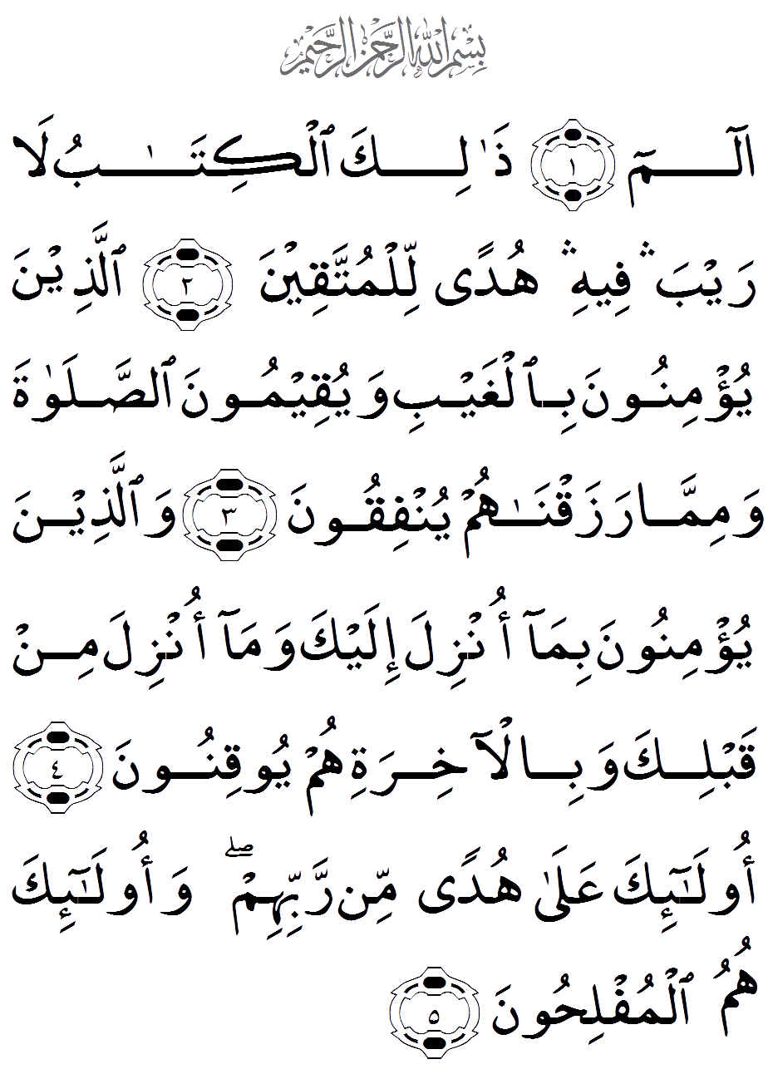

**Play Du'a**

**Reference**

Al-Bakarah Verse 1-5

**Pronunciation**

1. Alif-lam-meem.

2. Thalika alkitabu larayba feehi hudan lilmuttaqeen.

3. Allatheena yu/minoona bilghaybiwayuqeemoona assalata wamimma razaqnahumyunfiqoon.

4. Wallatheena yu/minoona bimaonzila ilayka wama onzila min qablika wabil-akhiratihum yooqinoon.

5. Ola-ika AAala hudan minrabbihim waola-ika humu almuflihoon.

**Translation**

1. Alif, Lam, Meem.

2. This is the Book about which there is no doubt, a guidance for those conscious of Allah.

3. Who believe in the unseen, establish prayer, and spend out of what We have provided for them.

4. And who believe in what has been revealed to you, [O Muhammad], and what was revealed before you, and of the Hereafter they are certain [in faith].

5. Those are upon [right] guidance from their Lord, and it is those who are the successful.

**Hadith/Benefit**

Ad-Darimi recorded that Ash-Sha`bi said that `Abdullah bin Mas`ud (R.A) (R.A) said, "Whoever recites ten verses from Surat Al-Baqarah in a night, then Shaytan will not enter his house that night. (The Dua’s are 1, 2, 3, 4, 5, 6, 7 and 8).

In another narration, Ibn Mas`ud (R.A) (R.A) said, "Then Shaytan will not come near him or his family, nor will he be touched by anything that he dislikes. Also, if these verses were to be recited over a senile person, they would wake him up.''

break

**Dua 3**

**Recite ONCE Between Asr to Magrib**

**Arabic**

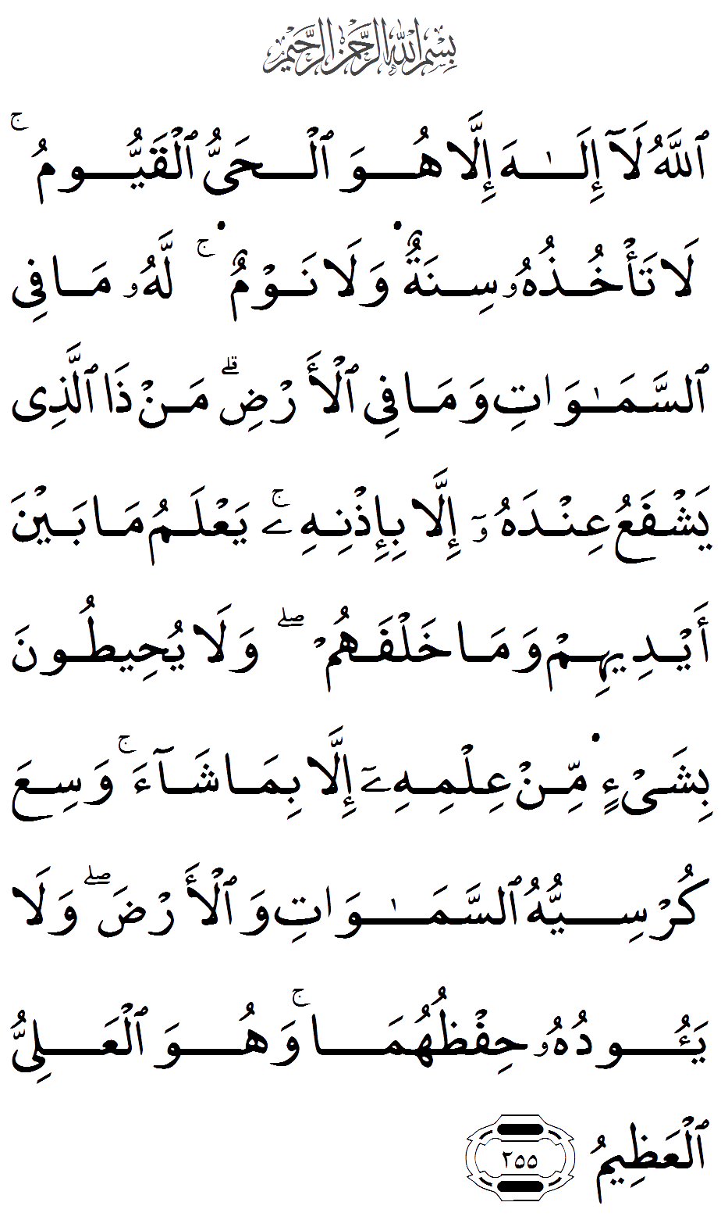

**Play Du'a**

**Reference**

Al-Bakarah verse 255, Ayatul Kursi

**Pronunciation**

255. Allahu la ilaha illahuwa alhayyu alqayyoomu la ta/khuthuhusinatun wala nawmun lahu ma fee assamawatiwama fee al-ardi man tha allatheeyashfaAAu AAindahu illa bi-ithnihi yaAAlamu mabayna aydeehim wama khalfahum wala yuheetoonabishay-in min AAilmihi illa bima shaawasiAAa kursiyyuhu assamawati wal-ardawala yaooduhu hifthuhumawahuwa alAAaliyyu alAAatheem

**Translation**

255. Allah – there is no deity except Him, the Ever-Living, the Sustainer of [all] existence. Neither drowsiness overtakes Him nor sleep. To Him belongs whatever is in the heavens and whatever is on the earth. Who is it that can intercede with Him except by His permission? He knows what is [presently] before them and what will be after them, and they encompass not a thing of His knowledge except for what He wills. His Kursi extends over the heavens and the earth, and their preservation tires Him not. And He is the Most High, the Most Great.

**Hadith/Benefit**

Narrated Abu Huraira (r.a) Allah 's Apostle ordered me to guard the Zakat revenue of Ramadan. Then somebody came to me and started stealing of the foodstuff. I caught him and said, "I will take you to Allah's Messenger (s.a.w)" Then Abu Huraira (r.a) described the whole narration and said: That person said (to me), "Please don't take me to Allah's Messenger (s.a.w) and I will tell you a few words by which Allah will benefit you. When you go to your bed, recite Ayat-al-Kursi, (2.255) for then there will be a guard from Allah who will protect you all night long, and Satan will not be able to come near you till dawn." When the Prophet (s.a.w) heard the story he said to me, "He who came to you at night, told you the truth although he is a liar; and it was Satan."

[Sahih al-Bukhari 5010 In-book reference: Book 66, Hadith 32]

break

**Dua 4**

**Recite ONCE Between Asr to Magrib**

**Arabic**

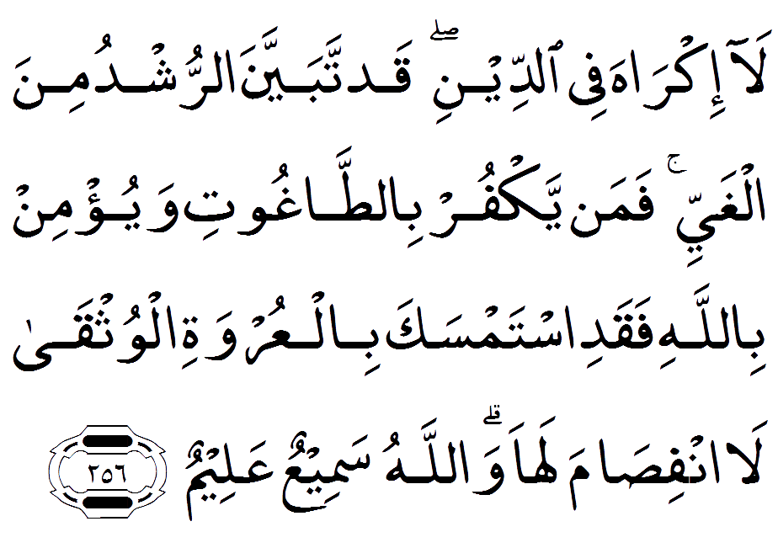

**Play Du'a**

**Reference**

Al-Bakarah verse 256

**Pronunciation**

256. La ikraha fee addeeniqad tabayyana arrushdu mina alghayyi faman yakfur bittaghootiwayu/min billahi faqadi istamsaka bilAAurwatialwuthqa la infisama laha wallahusameeAAun Aaaleem.

**Translation**

256. There shall be no compulsion in [acceptance of] the religion. The right course has become clear from the wrong. So whoever disbelieves in Taghut and believes in Allah has grasped the most trustworthy handhold with no break in it. And Allah is Hearing and Knowing.

**Hadith/Benefit**

Ad-Darimi recorded that Ash-Sha`bi said that `Abdullah bin Mas`ud (R.A) (R.A) said, "Whoever recites ten verses  from Surat Al-Baqarah in a night, then Shaytan will not enter his house that night. (The Dua’s are 1, 2, 3, 4, 5, 6, 7 and 8)

 In another narration, Ibn Mas`ud (R.A) said, "Then Shaytan will not come near him or his family, nor will he be touched by anything that he dislikes. Also, if these verses were to be recited over a senile person, they would wake him up.''

break

**Dua 5**

**Recite ONCE Between Asr to Magrib**

**Arabic**

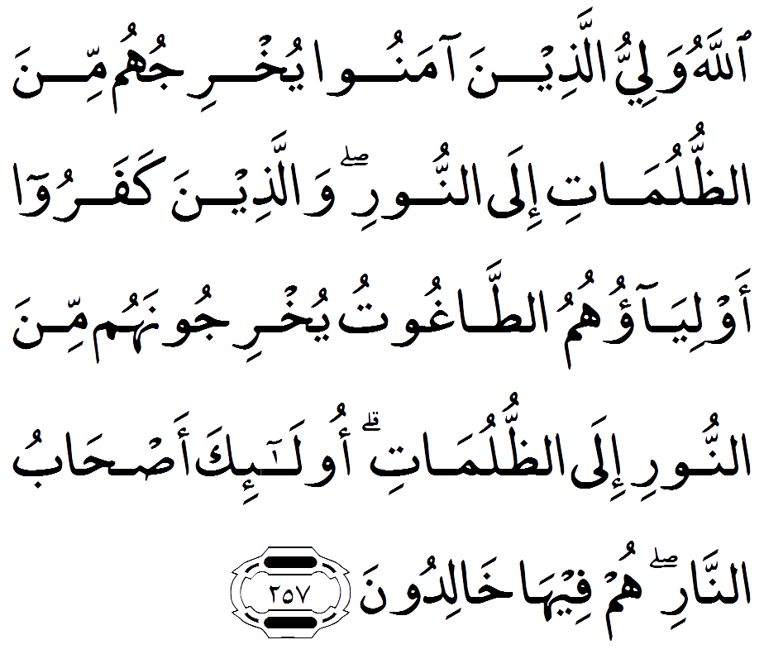

**Play Du'a**

**Reference**

Al-Bakarah verse 257

**Pronunciation**

257. Allahu waliyyu allatheena amanooyukhrijuhum mina aththulumati ilaannoori wallatheena kafaroo awliyaohumuattaghootu yukhrijoonahum mina annoori ilaaththulumati ola-ika as-habuannari hum feeha khalidoon.

**Translation**

257. Allah is the ally of those who believe. He brings them out from darknesses into the light. And those who disbelieve – their allies are Taghut. They take them out of the light into darknesses. Those are the companions of the Fire; they will abide eternally therein.

**Hadith/Benefit**

Ad-Darimi recorded that Ash-Sha`bi said that `Abdullah bin Mas`ud (R.A) (R.A) said, "Whoever recites ten verses  from Surat Al-Baqarah in a night, then Shaytan will not enter his house that night. (The Dua’s are 1, 2, 3, 4, 5, 6, 7 and 8)

 In another narration, Ibn Mas`ud (R.A) said, "Then Shaytan will not come near him or his family, nor will he be touched by anything that he dislikes. Also, if these verses were to be recited over a senile person, they would wake him up.''

break

**Dua 6**

**Recite ONCE Between Asr to Magrib**

**Arabic**

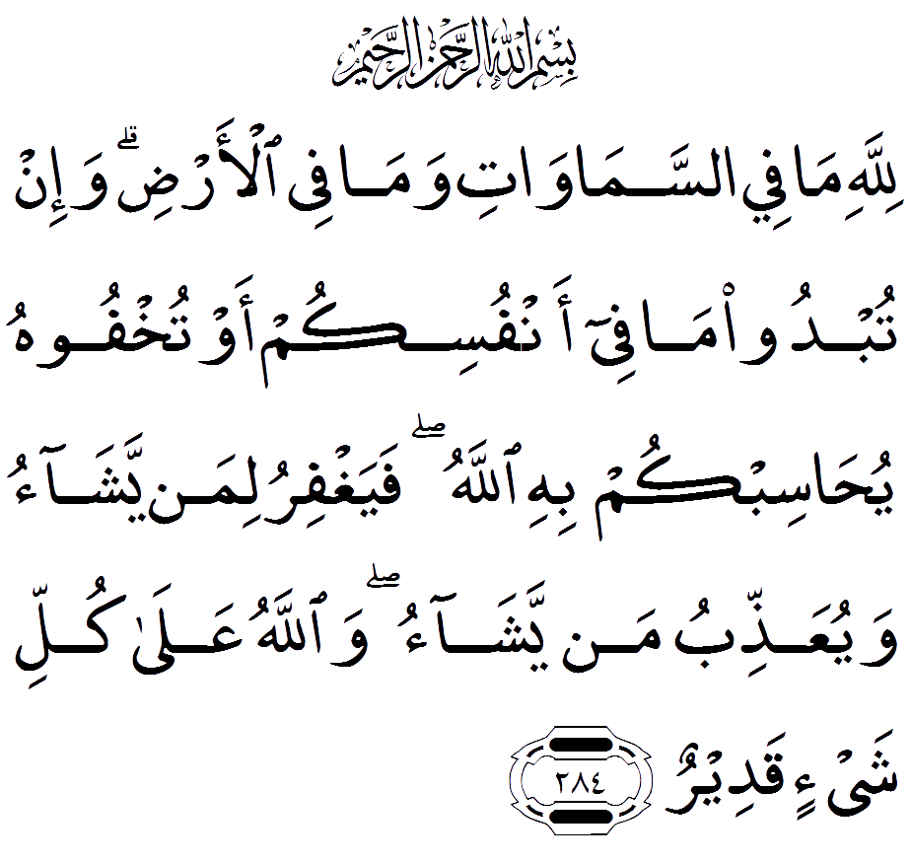

**Play Du'a**

**Reference**

Al-Bakarah verse 284

**Pronunciation**

284. Lillahi ma fee assamawatiwama fee al-ardi wa-in tubdoo ma feeanfusikum aw tukhfoohu yuhasibkum bihi Allahufayaghfiru liman yashao wayuAAaththibu man yashaowallahu AAala kulli shay-in qadeer.

**Translation**

284. To Allah belongs whatever is in the heavens and whatever is in the earth. Whether you show what is within yourselves or conceal it, Allah will bring you to account for it. Then He will forgive whom He wills and punish whom He wills, and Allah is over all things competent.

**Hadith/Benefit**

Ad-Darimi recorded that Ash-Sha`bi said that `Abdullah bin Mas`ud (R.A) (R.A) said, "Whoever recites ten verses  from Surat Al-Baqarah in a night, then Shaytan will not enter his house that night. (The Dua’s are 1, 2, 3, 4, 5, 6, 7 and 8)

 In another narration, Ibn Mas`ud (R.A) said, "Then Shaytan will not come near him or his family, nor will he be touched by anything that he dislikes. Also, if these verses were to be recited over a senile person, they would wake him up.''

break

**Dua 7**

**Recite ONCE Between Asr to Magrib**

**Arabic**

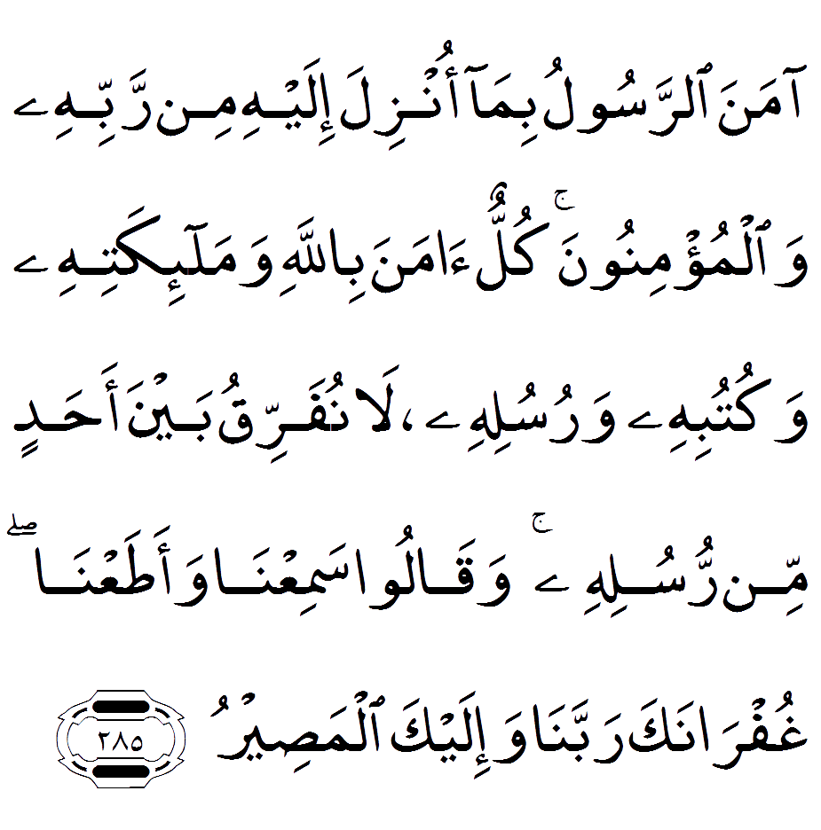

**Play Du'a**

**Reference**

Al-Bakarah verse 285

**Pronunciation**

285. Amana arrasoolu bimaonzila ilayhi min rabbihi walmu/minoona kullun amanabillahi wamala-ikatihi wakutubihiwarusulihi la nufarriqu bayna ahadin min rusulihiwaqaloo samiAAna waataAAna ghufranakarabbana wa-ilayka almaseer.

**Translation**

285. The Messenger has believed in what was revealed to him from his Lord, and [so have] the believers. All of them have believed in Allah and His angels and His books and His messengers, [saying], “We make no distinction between any of His messengers.” And they say, “We hear and we obey. [We seek] Your forgiveness, our Lord, and to You is the [final] destination.

**Hadith/Benefit**

The Prophet (S.A.W) said, “If somebody recites the last two verses of Chapter Al-Baqarah at night that will be sufficient for him.”

[Bukhari and Muslim]

# Also See Dua 1-6 #

break

**Dua 8**

**Recite ONCE Between Asr to Magrib**

**Arabic**

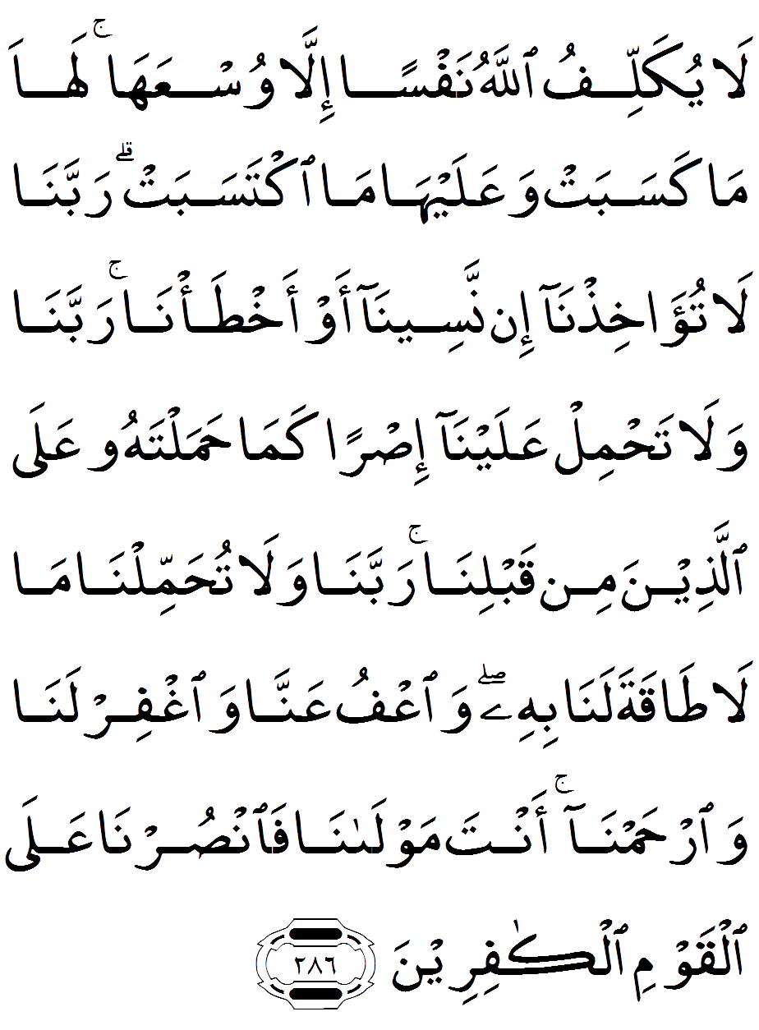

**Play Du'a**

**Reference**

Al-Bakarah verse 286

**Pronunciation**

286. La yukallifu Allahu nafsanilla wusAAaha laha ma kasabatwaAAalayha ma iktasabat rabbana latu-akhithna in naseena aw akhta/narabbana wala tahmil AAalayna isrankama hamaltahu AAala allatheena minqablina rabbana wala tuhammilnama la taqata lana bihi waAAfuAAanna waghfir lana warhamnaanta mawlana fansurna AAalaalqawmi alkafireen.

**Translation**

286. Allah does not charge a soul except [with that within] its capacity. It will have [the consequence of] what [good] it has gained, and it will bear [the consequence of] what [evil] it has earned. "Our Lord, do not impose blame upon us if we have forgotten or erred. Our Lord, and lay not upon us a burden like that which You laid upon those before us. Our Lord, and burden us not with that which we have no ability to bear. And pardon us; and forgive us; and have mercy upon us. You are our protector, so give us victory over the disbelieving people.

**Hadith/Benefit**

The Prophet (S.A.W) said, “If somebody recites the last two verses of Chapter Al-Baqarah at night that will be sufficient for him.”

[Bukhari and Muslim]

# Also See Dua 1-6 #

break

**Dua 9**

**Recite THREE times Between Asr to Magrib**

**Arabic**

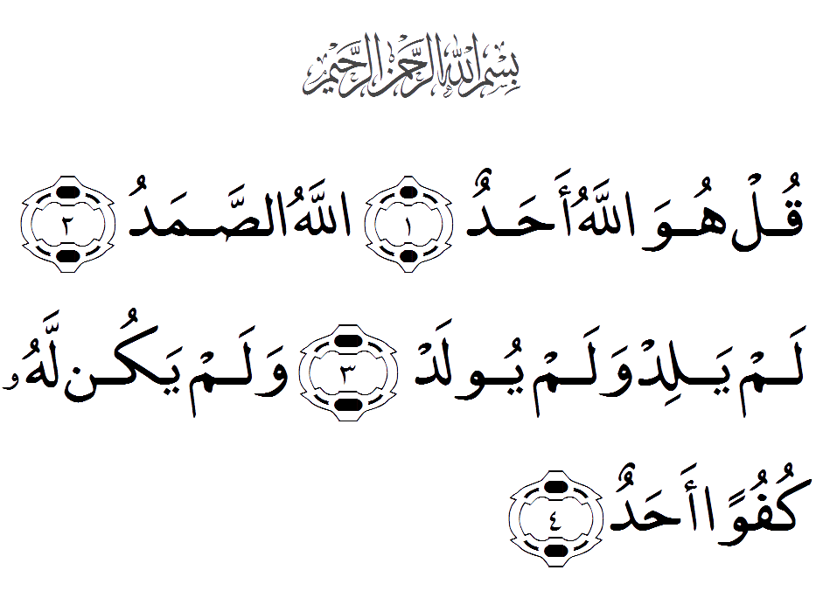

**Play Du'a**

**Reference**

Abu Dawud 2:86. An Nasa'i 3:68 also Al-Albani Sahih Timithi 2/8

**Pronunciation**

1. Qul huwa Allahu ahad

2. Allahu assamad

3. Lam yalid walam yoolad

4. Walam yakun lahu kufuwan ahad

**Translation**

1. Say, "He is Allah , [who is] One

2. Allah , the Eternal Refuge

3. He neither begets nor is born

4. Nor is there to Him any equivalent

**Hadith/Benefit**

Whoever recites (Three Qul) three times in the evening and in the morning will protect you against everything.

[Narrated by al-Tirmidhi, al-Da’waat, 3499, Sunan al-Tirmidhi, no. 2829]

break

**Dua 10**

**Recite THREE times Between Asr to Magrib**

**Arabic**

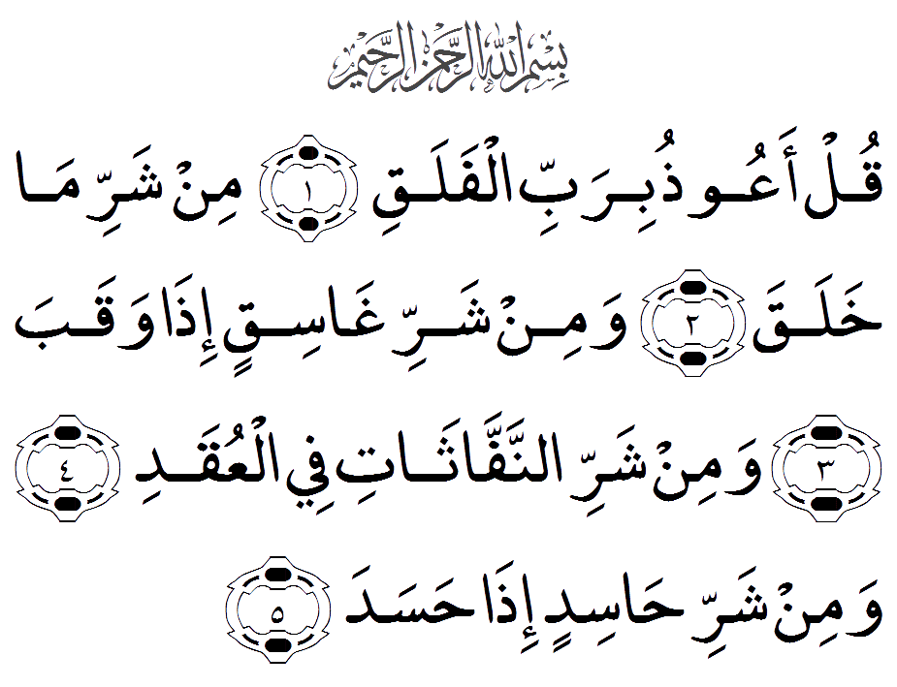

**Play Du'a**

**Reference**

Abu Dawud 2:86. An Nasa'i 3:68 also Al-Albani Sahih Timithi 2/8

**Pronunciation**

1. Qul aAAoothu birabbi alfalaq

2. Min sharri ma khalaq

3.Wamin sharri ghasiqin ithawaqab

4. Wamin sharri annaffathatifee alAAuqad

5. Wamin sharri hasidin itha hasad

**Translation**

1. Say, "I seek refuge in the Lord of daybreak

2. From the evil of that which He created

3. And from the evil of darkness when it settles

4. And from the evil of the blowers in knots

5. And from the evil of an envier when he envies

**Hadith/Benefit**

Whoever recites (Three Qul) three times in the evening and in the morning will protect you against everything.

[Narrated by al-Tirmidhi, al-Da’waat, 3499, Sunan al-Tirmidhi, no. 2829]

break

**Dua 11**

**Recite THREE times Between Asr to Magrib**

**Arabic**

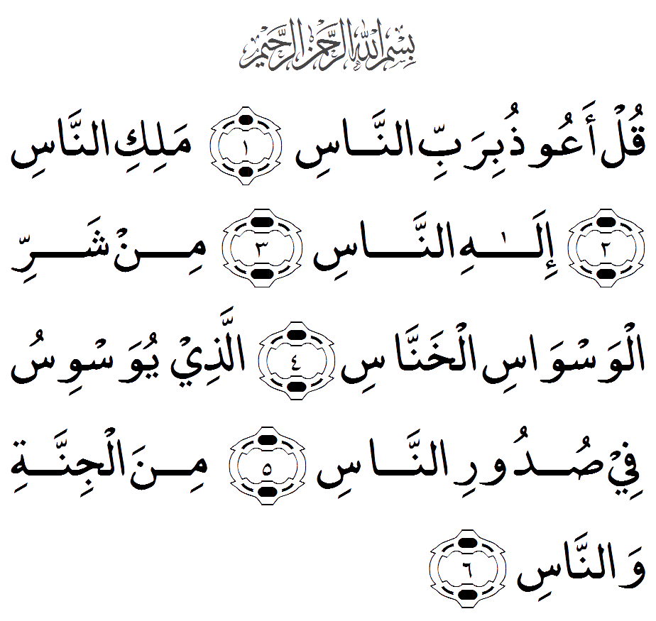

**Play Du'a**

**Reference**

Abu Dawud 2:86. An Nasa'i 3:68 also Al-Albani Sahih Timithi 2/8

**Pronunciation**

1. Qul aAAoothu birabbi annas

2. Maliki annas

3. Ilahi annas

4. Min sharri alwaswasi alkhannas

5. Allathee yuwaswisu fee sudoori annas

6. Mina aljinnati wannas

**Translation**

1 1.Say, "I seek refuge in the Lord of mankind

2. The Sovereign of mankind

3. The God of mankind

4. From the evil of the retreating whisperer

5. Who whispers [evil] into the breasts of mankind

6. From among the jinn and mankind

**Hadith/Benefit**

Whoever recites (Three Qul) three times in the evening and in the morning will protect you against everything.

[Narrated by al-Tirmidhi, al-Da’waat, 3499, Sunan al-Tirmidhi, no. 2829]

break

**Dua 12**

**Recite ONCE Between Asr to Magrib**

**Arabic**

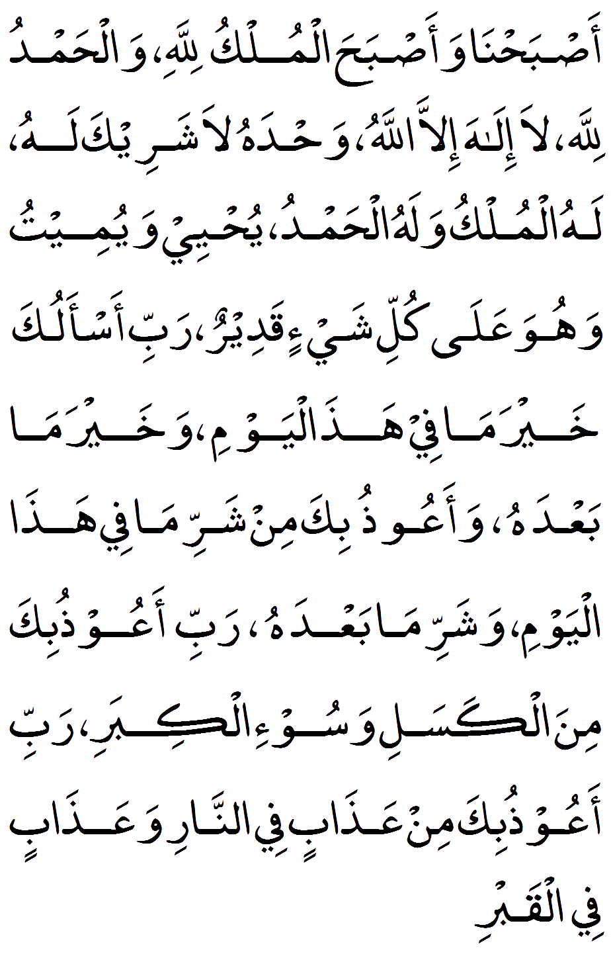

**Play Du'a**

**Reference**

Muslim – 4/2088, 2723 At-Trimidhi 3390

**Pronunciation**

Asbah'na wa as'bahal mulku lillah walhamdu lillah, La ilaha illal-lah, wahdahu la shareeka lah, lahul-mulku walahul-hamd, Yohee wa yumeeto wahuwa ala kulli shayin qadeer, Rabbi as-aluka khayrama fee hazal yawm wa-khayra ma ,Ba'daha wa-aoozu-bika min sharri ha'zaal-yawm, washarri ma, Ba'daha rabbi aa'ozu-bika minal-kasal, wasoo-il kibar, Rabbi aa'ozubika min aa'zaa-bin fin-nar, wa aa'zaa-bin fil-qabr

**Translation**

We have reached the morning and at this very time unto Allah belongs all sovereignty, and all praise is for Allah. None has the right to be worshipped except Allah, alone, without partner, to Him belongs all sovereignty and praise and He is over all things omnipotent.My Lord, I ask You for the good of this day and the good of what follows it and I take refuge in You from the evil of this day and the evil of what follows it. My Lord, I take refuge in You from laziness and senility. My Lord, I take refuge in You from torment in the Fire and punishment in the grave

**Hadith/Benefit**

The Prophet (S.A.W) used to say this Dua in the evening.

[Tirmidhi 2699, al-Daw’aat, 3390; classed as Sahih by al-Albani]

break

**Dua 13**

**Recite ONCE Between Asr to Magrib**

**Arabic**

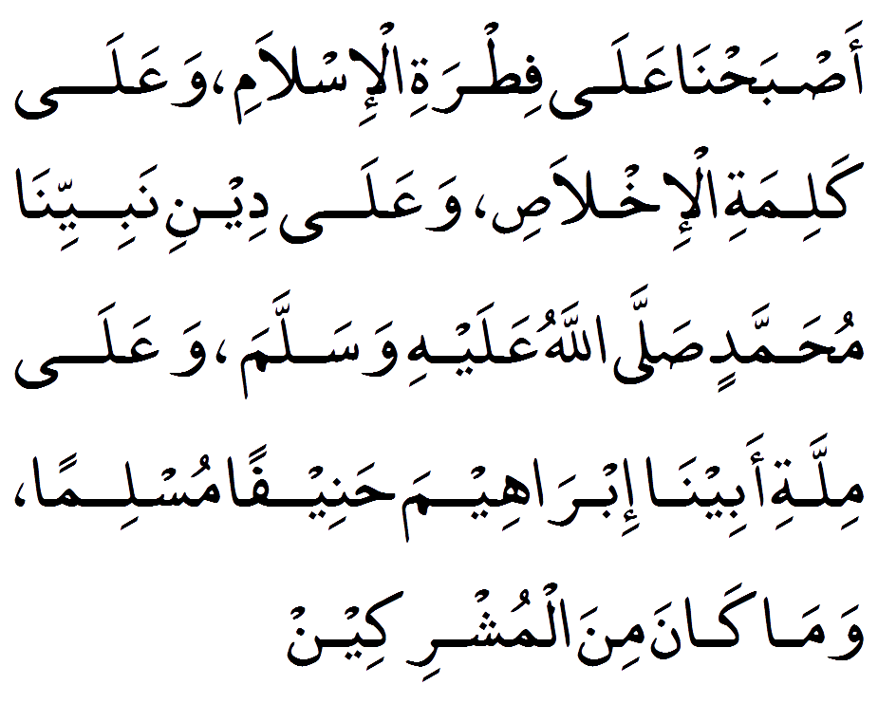

**Play Du'a**

**Reference**

Ahmad 15367, Sahih Al-Jami' 4674

**Pronunciation**

Asbah'na ala fitratil-islam, Wa'ala kalimatil-ikhlas, Wa'ala deeni nabiyyina Muhammad (Sallalla-hu alai hi wasallam), Wa'ala millati abeena Ibraheema haneefan musliman, Waama kana minal-mushrikeen

**Translation**

We rise upon the fitrah of Islaam, and the word of pure faith, and upon the religion of our Prophet Muhammad and the religion of our forefather Ibraheem, who was a Muslim and of true faith and was not of those who associate others with Allaah

**Hadith/Benefit**

This day, I have perfected your religion for you, completed My Favour upon you, and have chosen for you Islam as your religion”

[Al-Maa’idah 5:3]

So whatever was not part of the religion of Islam at that point should never be part of the religion of Islam today. The Sahabas (R.A) Taabi’een and Imams issued many warnings against innovation (Bid'ah).

Hudhayfah ibn al-Yamaan (R.A) said, every act of worship which the companions of the Messenger of Allaah (S.A.W) did not do, do not do it.

Ibn Mas’ood (R.A) said, follow and do not innovate, for the religion is complete. Adhere to the old way (i.e the way of the Prophet (S.A.W) and the Sahabas (R.A).

break

**Dua 14**

**Recite ONCE Between Asr to Magrib**

**Arabic**

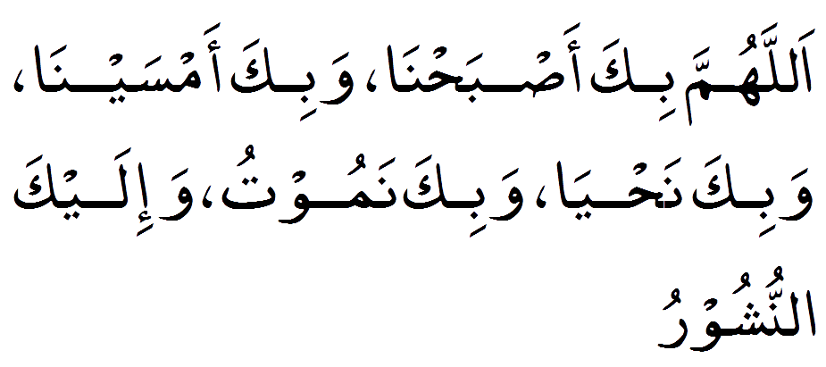

**Play Du'a**

**Reference**

Abu Dawud 5068, At-Tirmidhi 3391, Ibn Majah 3868

**Pronunciation**

Allahumma bika Asbah'na, wabika amsayna Wabika nahya wabika namootu wa-ilaykal-nushoor

**Translation**

O Allah, by Your leave we have reached the morning and by Your leave we have reached the evening by Your leave we live and die and unto You is our return

**Hadith/Benefit**

The Messenger of Allah (S.A.W) taught his companions to say (this Du'a) in the evening/morning.

[Tirmidhi, al-Da’waat, 3391, classed as Sahih by al-Albani, no. 2700]

break

**Dua 15**

**Recite THREE times Between Asr to Magrib**

**Arabic**

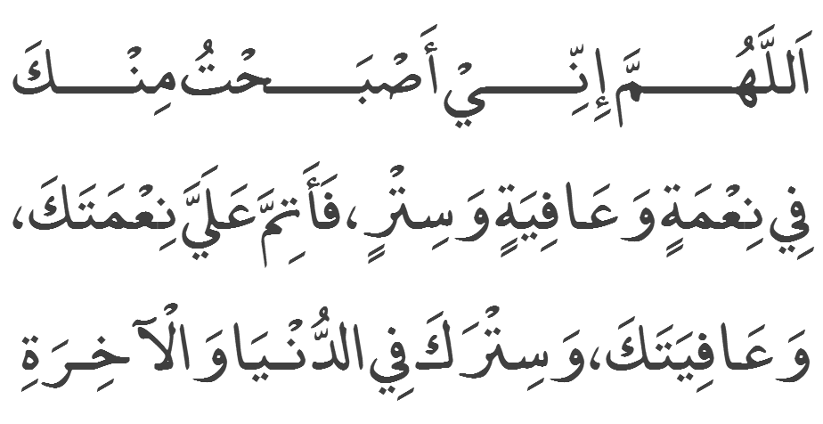

**Play Du'a**

**Reference**

Kitab al Azkar Al-Uthaymeen, Ibn Sonny

**Pronunciation**

Allahumma inni aas,bahtu minka ,Fi nimatin wa afiyatin wa sitr, fa atimma alayya ni'mataka ,Wa afiyataka wa sitraka fi-dunya wa al akhira

**Translation**

O Allah, I rose up in the evening with blessings, strength and concealment (of my shortcomings), all of which are from You. So complete all the blessings and strength from You and the concealment for me in this life and the hereafter

**Hadith/Benefit**

# BENEFIT NOT AVAILABLE #

REQUEST:  Please send us the virtue/benefit of this Du'a and InshAllah we will publish on next update.

break

**Dua 16**

**Recite ONCE Between Asr to Magrib**

**Arabic**

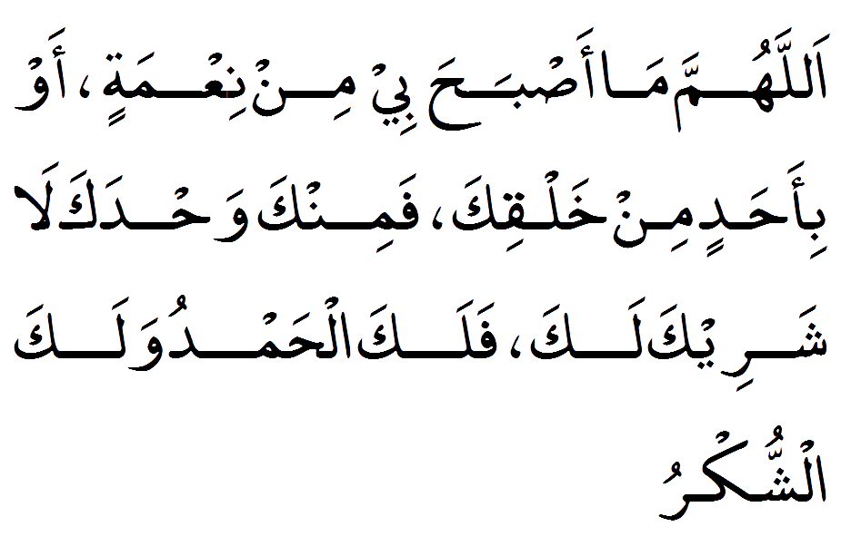

**Play Du'a**

**Reference**

Abu Dawood Book 4 hadith 324

**Pronunciation**

Allahumma ma aas'baha bee min nia'matin, Wa bi-ahadin min khalqik, Faminka wahdaka la shareeka lak, Falakal-hamdu walakash-shukr

**Translation**

O Allah, what blessing I or any of Your creation have risen upon, is from You alone, without partner, so for You is all praise and unto You all thanks, O Allah, what blessing I or any of Your creation have risen upon, is from You alone, without partner, so for You is all praise and unto You all thanks.’

**Hadith/Benefit**

The Prophet (S.A.W) said, “Whoever says this in the morning has indeed offered his day’s thanks and whoever says this in the evening has indeed offered his night’s thanks”.

Allah says in the Qur’an, “Indeed if you are grateful and give thanks, surely, definitely I will increase you; but if you are ungrateful, then know that my punishment is indeed most severe”

[Sura Ibrahim verse.7]

break

**Dua 17**

**Recite ONCE Between Asr to Magrib**

**Arabic**

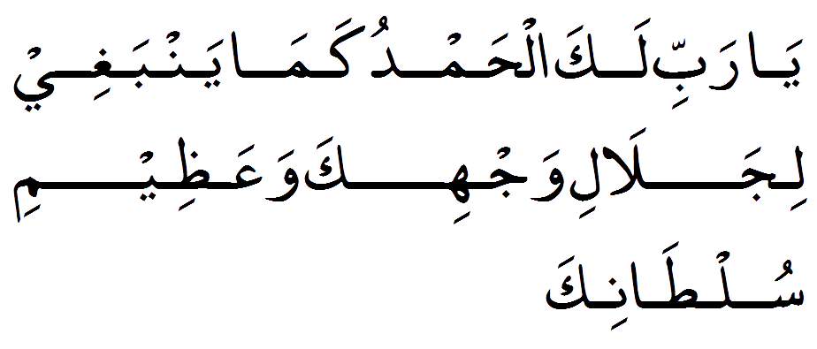

**Play Du'a**

**Reference**

Kitab al Azkar Al-Uthaymeen, Itahzeeb Al-Kamali Lilmazi

**Pronunciation**

Yaa rabbil lakal"hamdu kama yanbaghii lijalaali wajhika, wa'aziimi sultaanik

**Translation**

O my Lord, all praises be to You as it should be due to Your Might and the Greatness of Your Power

**Hadith/Benefit**

Abdullah bin Umar (R.A) narrated the Prophet (S.A.W) talked about a servant of the Servants of God said (This Du'a…) then two angels feel heavy and do not know how to register (rewards) and they ascended to Allah and said "O our Lord, We DO NOT know how record his reward when he said this words “He replied, "What did he said? “Angel second replied “he says Ya Rabbi….and Allah SWT replied "write reward as what just spoken by him until he meets me, I will reward him.

[Imam Ahmed, Ibn Majah]

break

**Dua 18**

**Recite THREE times Between Asr to Magrib**

**Arabic**

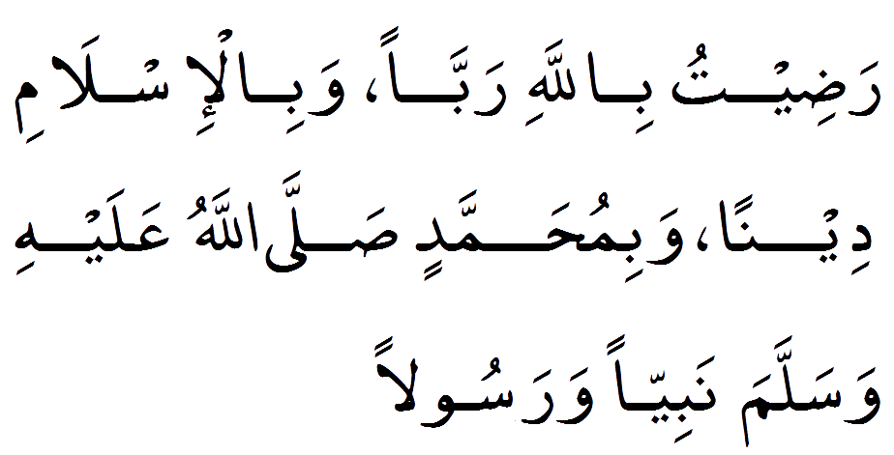

**Play Du'a**

**Reference**

Abu Dawood Book 4 hadith 318

**Pronunciation**

Radeetu billahi rabban wabil-islami deenan wabiMuhammadin sal-lalla-hu alaihi wasallam nabiyya wa rasulaan

**Translation**

I am pleased with Allah as a Lord, and Islam as a religion and Muhammad peace be upon to him as a Prophet

**Hadith/Benefit**

Allah has promised that anyone recites (this Du’a) in the morning and evening will be pleased on the day of resurrection.

[Ahmed 4/337, An-Nasa’i from Hisnul Muslim]

break

**Dua 19**

**Recite ONCE Between Asr to Magrib**

**Arabic**

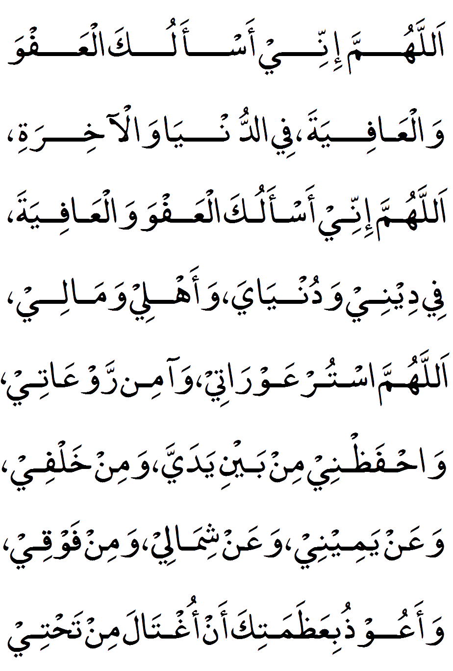

**Play Du'a**

**Reference**

Ibn Majah Book 2 hadith 323

**Pronunciation**

Allahumma innee as-alukal-AAafwa walAAafiyah, fid-dunya wal-akhirah, allahumma innee as-alukal-AAafwa walAAafiyah fee deenee, wadunyaya wa-ahlee, wamalee, allahummas-tur AAawratee, wa-amin rawAAatee, wah-faaz’nee min bayni yaday, wamin khalfee, waAAan yameenee, waAAan shimalee, wamin fawqee, wa-aAAoothu biAAathamatika an oghtala min tahtee

**Translation**

O Allah, I ask You for pardon and well-being in this life and the next. O Allah, I ask You for pardon and well-being in my religious and worldly affairs, and my family and my wealth. O Allah, veil my weaknesses and set at ease my dismay, and preserve me from the front and from behind and on my right and on my left and from above, and I take refuge with You lest I be swallowed up by the earth.

**Hadith/Benefit**

The Messenger of Allah (S.A.W) never missed to reciting this Du’a in the evening and in the morning.

[Abu Dawood, al-Adab, 5074]

break

**Dua 20**

**Recite THREE times Between Asr to Magrib**

**Arabic**

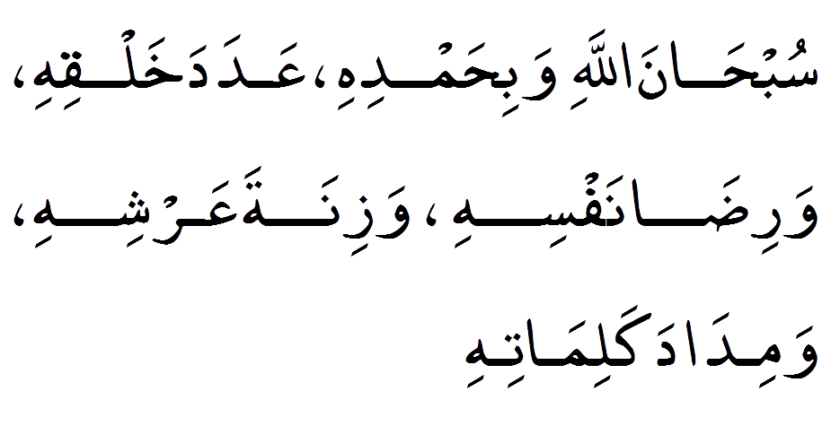

**Play Du'a**

**Reference**

Sahih Muslim – Book 4/2090

**Pronunciation**

Subhanal-lahi wabihamdih, Aa'dada khalqihi warida nafsih, wazinata aa'rshih, wamidada kalimatih

**Translation**

How perfect Allah is and I praise Him by the number of His creation and His pleasure, and by the weight of His throne, and the ink of His words

**Hadith/Benefit**

The recitation of the words quoted in this Hadith is highly meritorious and rewarding because they are full of Praise and Glorification of Allah.

[Riyad-us-Saliheen – Hadith No 1433]

break

**Dua 21**

**Recite THREE times Between Asr to Magrib**

**Arabic**

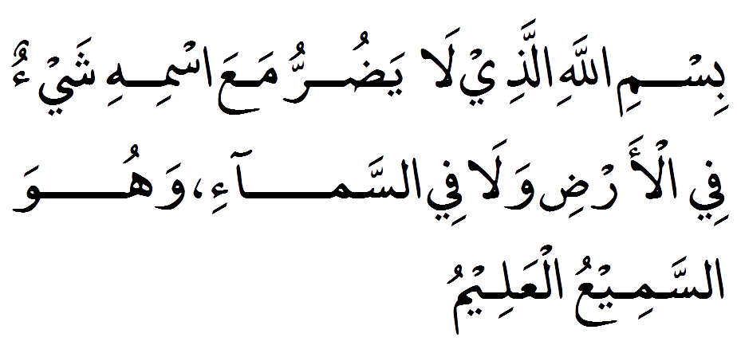

**Play Du'a**

**Reference**

Abu Dawood Book 4/323, At-Trimithi 5/465

**Pronunciation**

Bismil-lahil-lazee la-ydur-ru ma'aas-mihi shay-on fil-ardi wala fis-sama-i wahuwas-sameeul-aa'leem

**Translation**

In the name of Allah with whose name nothing is harmed on earth nor in the heavens and He is The All-Seeing, The All-Knowing

**Hadith/Benefit**

The Messenger of Allah (S.A.W) said whoever recites this Dua three times, nothing will harm him.

[At-Tirmidhi, al-Da’waat, 3388]

break

**Dua 22**

**Recite THREE times Between Asr to Magrib**

**Arabic**

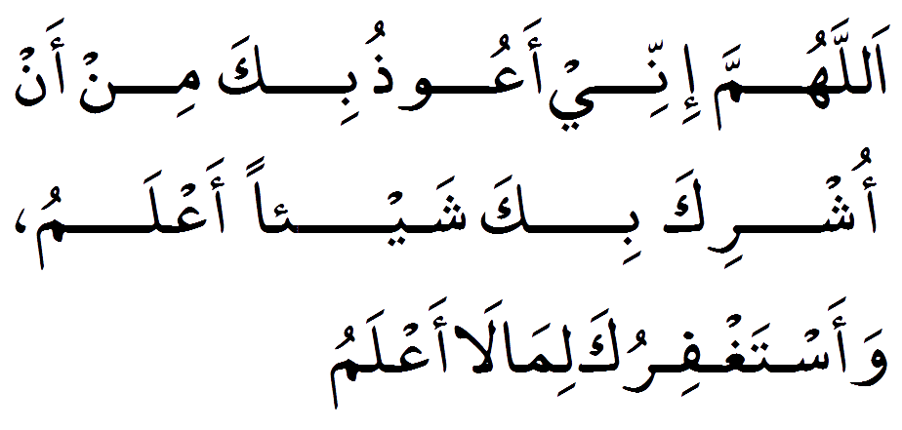

**Play Du'a**

**Reference**

Kitab al Azkar Al-Uthaymeen, Ahadith Mokhtara Limaqdesy

**Pronunciation**

Allah humma inni aa-uzubika min in'ooshu-riak bika shai'an aalamu wa aastagfiruka lema la aalaam

**Translation**

O Allah, I take refuge in You lest I should commit shirk with You knowingly and I seek Your forgiveness for what I do unknowingly

**Hadith/Benefit**

The Messenger (S.A.W) warned us against shirk, fearing that his Ummah might fall into it, and said “The thing I fear most for you is minor shirk.”

[Narrated by Ahmad, 23119]

 Also he said: “Shirk among you is more subtle than the sound of the footsteps of an ant on a rock. Shall I not tell you of something which, if you do it, it will take that away from you both minor and major forms of it” (Saying this Du’a).

[Sahih al-Jaami 2876]

break

**Dua 23**

**Recite THREE times Between Asr to Magrib**

**Arabic**

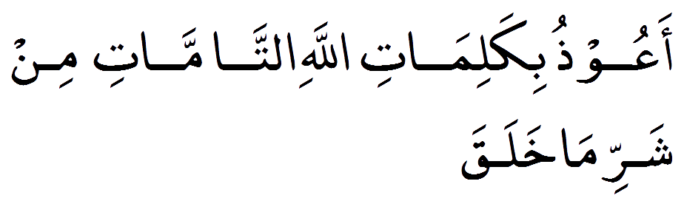

**Play Du'a**

**Reference**

Ahmed Book 2 hadith 290

**Pronunciation**

Aa'oozu bikalimatil-lahit-tammati min sharri ma khalaq

**Translation**

I take refuge in Allah’s perfect words from the evil He has created

**Hadith/Benefit**

Narrated by Khawlah bint Hakeem Al-Sulamiyyah said I heard Prophet (S.A.W) said, “Whoever make a stop on a journey and say this Dua, nothing will harm him until he moves on from that place”.

[Narrated by Muslim 2708]

break

**Dua 24**

**Recite ONCE Between Asr to Magrib**

**Arabic**

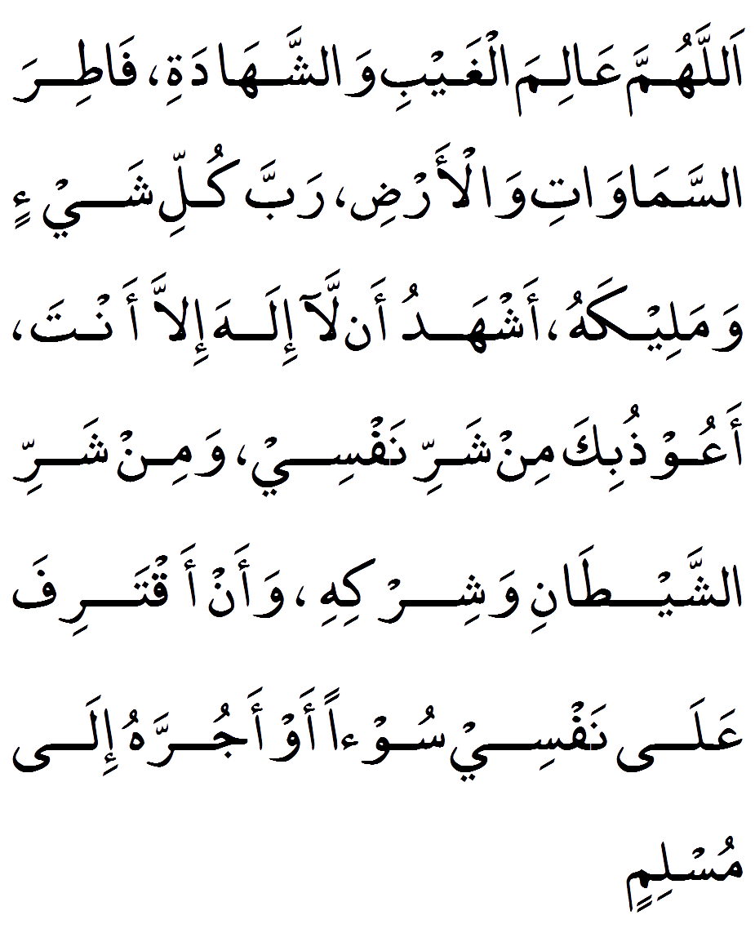

**Play Du'a**

**Reference**

Sahih Thirmidi Book 3/142

**Pronunciation**

Allahumma AAalimal-ghaybi washshahadah,Fatiras-samawati wal-ard,Rabba kulli shayin wa-ma-leekah, Ashhadu an-alaa ilaha illa ant, Aa'oozu-bika min sharri nafsee wamin shar-rish-shaytani wa-shirk, Wa'an aq-tarifa ala nafsee soo-an aw aa-jur-rahu ila muslim

**Translation**

O Allah, Knower of the unseen and the seen, Creator of the heavens and the Earth, Lord and Sovereign of all things, I bear witness that none has the right to be worshipped except You. I take refuge in You from the evil of my soul and from the evil and shirk of the devil, and from committing wrong against my soul or bringing such upon another Muslim

**Hadith/Benefit**

The Prophet (S.A.W) taught one of his companions and he said: “Say this in the morning and in the evening, and when you go to your bed.”

[At-Tirmidhi, al-Da’waat, 3392]

break

**Dua 25**

**Recite ONCE Between Asr to Magrib**

**Arabic**

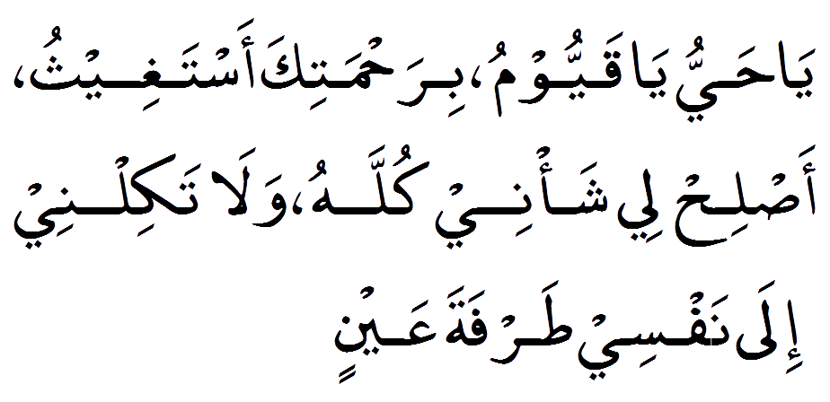

**Play Du'a**

**Reference**

Sahih Tergib Ue Terhib 1/273

**Pronunciation**

Ya hayyu ya qayyoom, birahmatika astagheeth, aas-lih lee sha'nee kullah, wala takilnee ila nafsee tarfata aay'in

**Translation**

O Ever Living,O Self-Subsisting & Supporter of all, by Your mercy I seek assistance, rectify for me all of my affairs & do not leave me to myself, even for the blink of an eye

**Hadith/Benefit**

Anas ibn Maalik (R.A) reports that Prophet (S.A.W) once mentioned to Fatima (R.A) to recite the following supplication morning and evening.

[Imaam Haakim and Imaam Dhahabiy]

 Also Abdullah ibn Mas'ood (R.A) narrated that whenever Prophet (S.A.W) used to be afflicted in any worry or concern; he used to recite this supplication.

[Mustadrak al-Haakim vol.1 pg.509]

break

**Dua 26**

**Recite ONCE Between Asr to Magrib**

**Arabic**

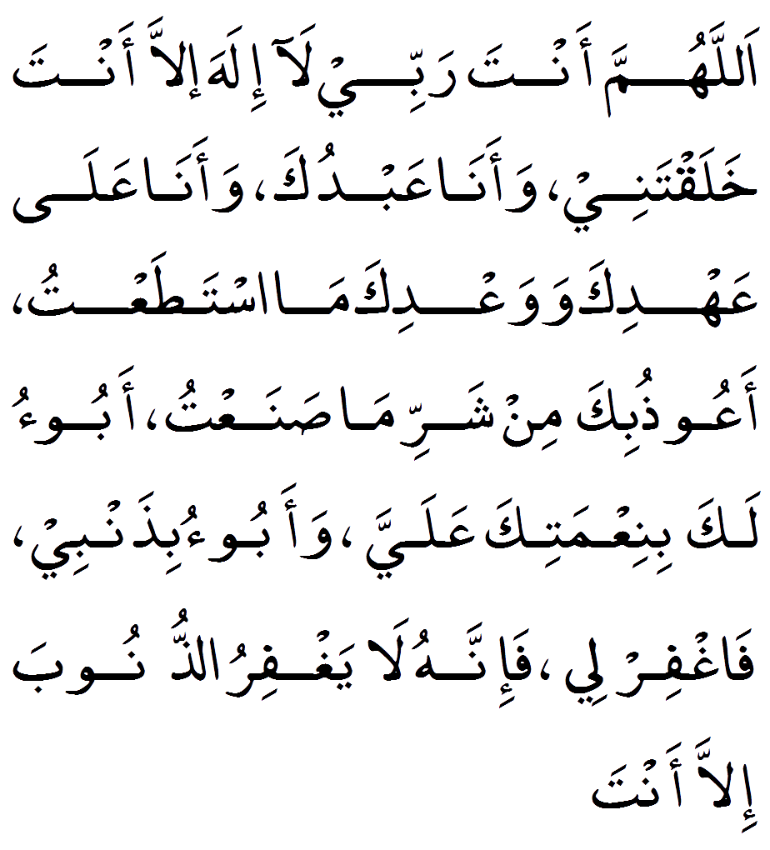

**Play Du'a**

**Reference**

Al Bhukari 7/150

**Pronunciation**

Allahumma anta rabbee la ilaha illa ant, Khalaq-tanee wa-ana aabduk, Wa-ana ala aah-dika wa wa'dika mas-ta-taat, Aa'oozu'bika min sharri ma sanath, Aboo-o laka bini'matika aa'aly, wa-aboo-o bi-zan-bee, Faghfir lee fa-innahu la yagh-firu-zunooba illa ant

**Translation**

O Allah, You are my Lord, none has the right to be worshipped except You, You created me and I am Your servant and I abide to Your covenant and promise as best I can, I take refuge in You from the evil of which I have committed. I acknowledge Your favor upon me and I acknowledge my sin, so forgive me, for verily none can forgive sin except You

**Hadith/Benefit**

The Prophet (S.A.W) said, Whoever says this during the day, believing in it with certainty, then dies on that day before evening comes, will be one of the people of Paradise, and whoever says it at night, believing in it with certainty, then dies on that night before morning comes, will be one of the people of Paradise.”

[Bukhari: 7/150, al-Da’waat, 6306]

break

**Dua 27**

**Recite FOUR times Between Asr to Magrib**

**Arabic**

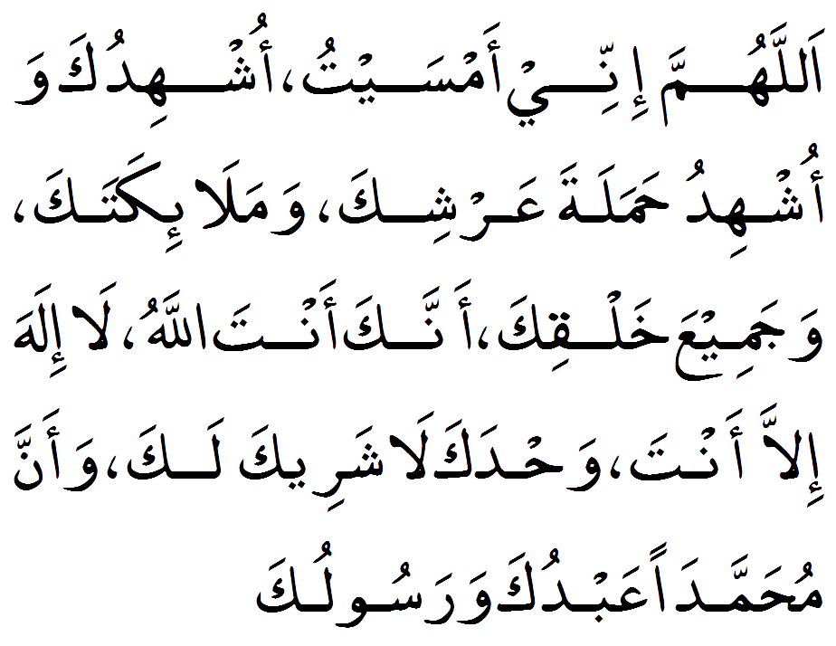

**Play Du'a**

**Reference**

Abu Dawood Book 4 hadith 317

**Pronunciation**

Allahumma innee aamsaitu oshhiduk, Wa-oshhidu hamalata aarshik, Wamala-ikatik, Wa-jamee'aa khalqik, ann-naka antal-lahu la ilaha illa ant, Wah'daka la shareeka lak, Wa-anna Muhammadan aabdu-ka wa-rasooluk

**Translation**

O Allah, ily I have reached the morning and call on You, the bearers of Your throne, Your angels, and all of Your creation to witness that You are Allah, ne has the right to be worshipped except You, alone, without partner and that Muhammad is Your Servant and Messenger

**Hadith/Benefit**

Anas ibn Malik (R.A) the Prophet (S.A.W) said, “if anyone says (this Du'a) in the morning or in the evening Allah (SWT) will emancipate his fourth from hell, if anyone says twice Allah will emancipate his half, if anyone says it thrice, Allah will emancipate three-fourth and if he says four times, Allah will emancipate him from hell”.

[Sunan Abu Dawud, Book 41, Hadith 5051]

break

**Dua 28**

**Recite THREE times Between Asr to Magrib**

**Arabic**

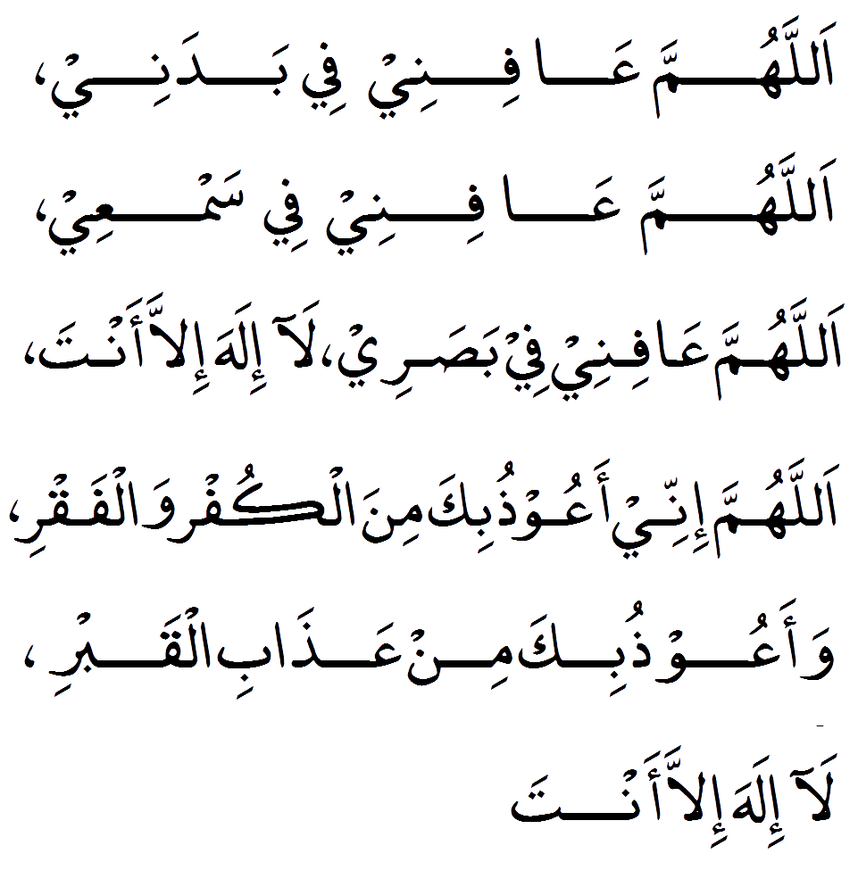

**Play Du'a**

**Reference**

Abu Dawood Book 4 hadith 324

**Pronunciation**

Allahumma aa'fi-nee fee badanee, Allahumma a'fi-nee fee sam'ee, Allahumma aa'fi-nee fee basa'ree, la ilaha illa-ant, Allahumma innee aa'oozu-bika minal-kufr, wal-faqr, Wa-aa'oo-zu-bika min aazaabil-qabr, la ilaha illa-ant

**Translation**

O Allah, grant my body health, O Allah, grant my hearing health, O Allah, grant my sight health. None has the right to be worshipped except You ,  O Allah, I take refuge with You from disbelief and poverty, & I take refuge with You from the punishment of the grave. None has the right to be worshipped except You

**Hadith/Benefit**

Whoever recites this in the evening has completed his obligation for the night.

[Abu Dawud 4/318]

break

**Dua 29**

**Recite SEVEN times Between Asr to Magrib**

**Arabic**

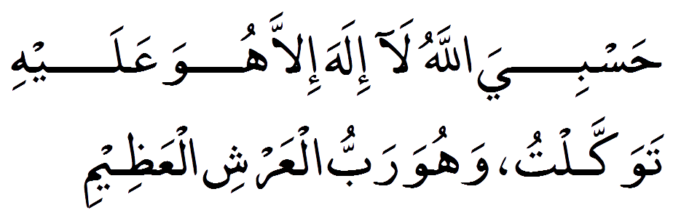

**Play Du'a**

**Reference**

Abu Dawood Book 4 hadith 321

**Pronunciation**

Hasbiyal-lahu la ilaha illa huwa, aa'layhi tawakkalt, wahuwa rabbul-aarshil-aazeem

**Translation**

Allah is Sufficient for me, none has the right to be worshipped except Him, upon Him I rely and He is Lord of the exalted throne

**Hadith/Benefit**

Whoever recites this Allah will grant whatever he/she desire from this world or next.

[Abu Dawud 4/321]

break

**Dua 30**

**Recite ONCE times Between Asr to Magrib**

**Arabic**

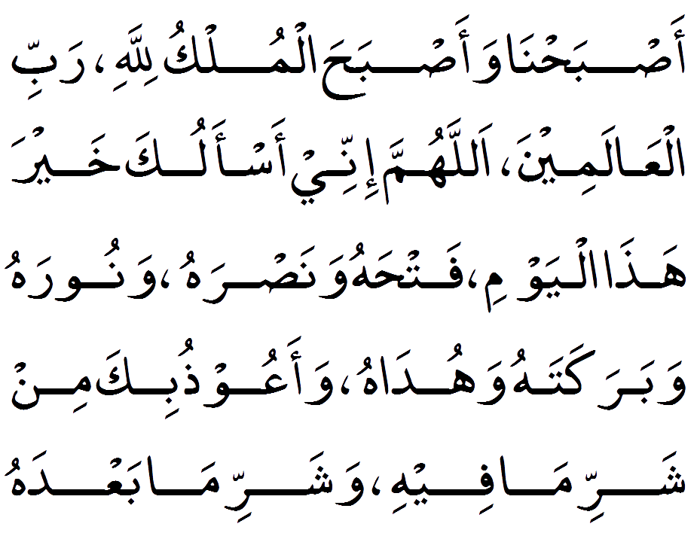

**Play Du'a**

**Reference**

Abu Dawood Book 4 hadith 322

**Pronunciation**

Asbahna wa-asbahal mulku, Lillahi rabbil-aa'la-meen, Allahumma innee as-aluka khayra ha-zal-yawm, Fat-hahu, wa-nas-rahu,wa-noo-rahu, wa-baraka-tahu,wahu-dahu, Wa-aa'oozu-bika min sharrima feehi wa-shar-ri ma baa'dah

**Translation**

We have reached the morning and at this very time all sovereignty belongs to Allah, Lord of the worlds. O Allah, I ask You for the good of this day, its triumphs and its victories, its light & its blessings and its guidance, and I take refuge in You from the evil of this day and the evil that follows it.

**Hadith/Benefit**

# BENEFIT NOT AVAILABLE #  
REQUEST:  Please send us the virtue/benefit of this Du'a and InshAllah we will publish on next update.

break

**Dua 31**

**Recite 100 times Between Asr to Magrib**

**Arabic**

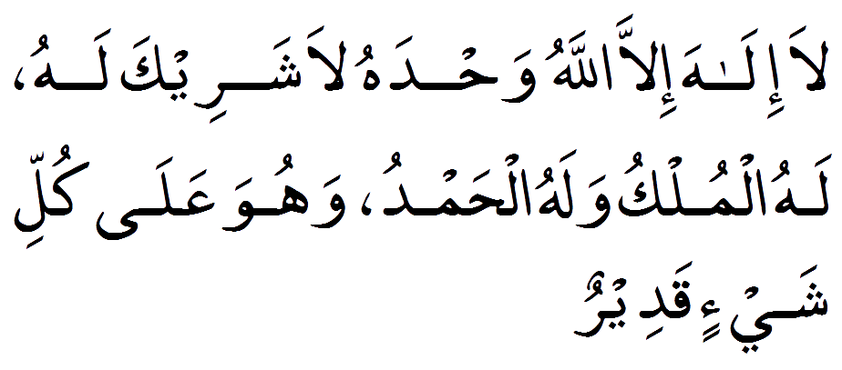

**Play Du'a**

**Reference**

Muslim Book 4 hadith 2071

**Pronunciation**

Laa ilaaha ill-allaahu, waḥdahu laa shareeka lahu, lahul-mulku wa lahul-ḥamdu, wa huwa ‛alaa kulli shay’in qadeer

**Translation**

None has the right to be worshipped except Allah, alone, without partner, to Him belongs all sovereignty and praise, and He is over all things omnipotent.

**Hadith/Benefit**

Narrated Abu Huraira (R.A) Allah's Apostle said, " Whoever says: "La ilaha illal-lah…., one hundred times will get the same reward as given for manumitting ten slaves; and one hundred good deeds will be written in his accounts, and one hundred sins will be deducted from his accounts, and it (his saying) will be a shield for him from Satan on that day till night, and nobody will be able to do a better deed except the one who does more than he”.

[Bhukari Volume 8, Book 75, Number 412]

break

**Dua 32**

**Recite 100 times Between Asr to Magrib**

**Arabic**

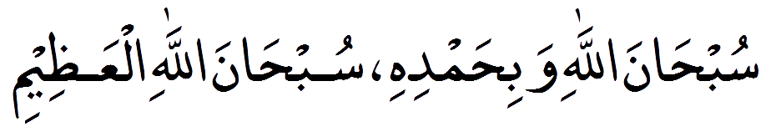

**Play Du'a**

**Reference**

Bukhari 6405, Muslim 4/2071

**Pronunciation**

Subhanallah wa bi-hamdihi, Subhanallah al-azim

**Translation**

All Glory is to Allah and all Praise to Him,Glorified is Allah, the Great

**Hadith/Benefit**

Abu Hurayrah (R.A.) reported that the Messenger of Allah (S.A.W) said, there are two words which are light on the tongue, heavy on the Scale and beloved to The Most Gracious.

Narrated Abu Hurayrah (R.A) Allah's Apostle said "Whoever says, 'Subhan Allah wa bihamdihi,' one hundred times a day, will be forgiven all his sins even if they were as much as the foam of the sea.

[Bhukari Volume 8, Book 75, Number 414]